

*Where heaven meets earth­ – the breath taking architecture of the church soaring towards the heavens, a testament to humanity’s boundless faith and unwavering spirit.*

*.*

*Echoes of Today’s Music: How it Resonates with Children’s Perception of the World.*

.

*Disconnected from Reality: The dangerous rise of phone addiction – Teenagers glued to their screens, unaware of their surroundings.*

.

*The next generation of trendsetters takes over. A kid embracing the most recent fashion trend.*.

*Back to Basics: A child rediscovers the simple pleasures of running and playing outside.*

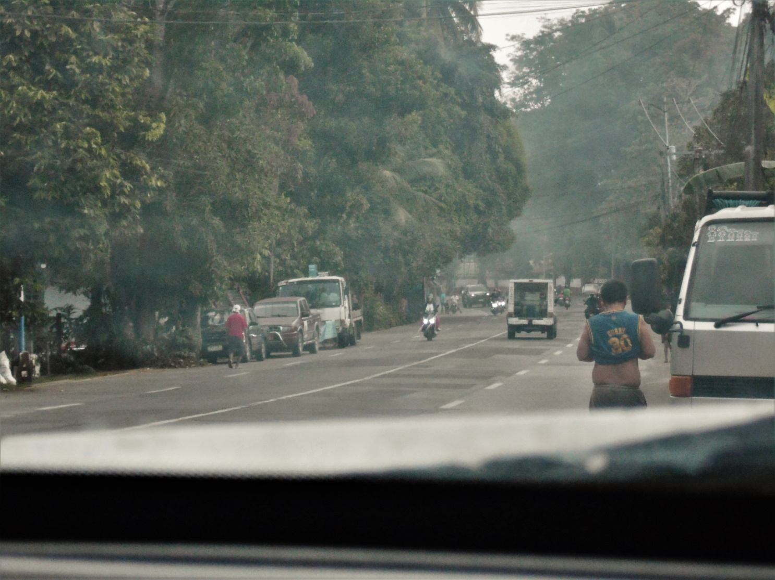.

*Another Day Begins: The early morning city streets bustles as people start their day.*.

.

*The Face of Poverty: A blind beggar’s asking hands tells a story of struggle.*

.

*Hotdog po literal hehe*

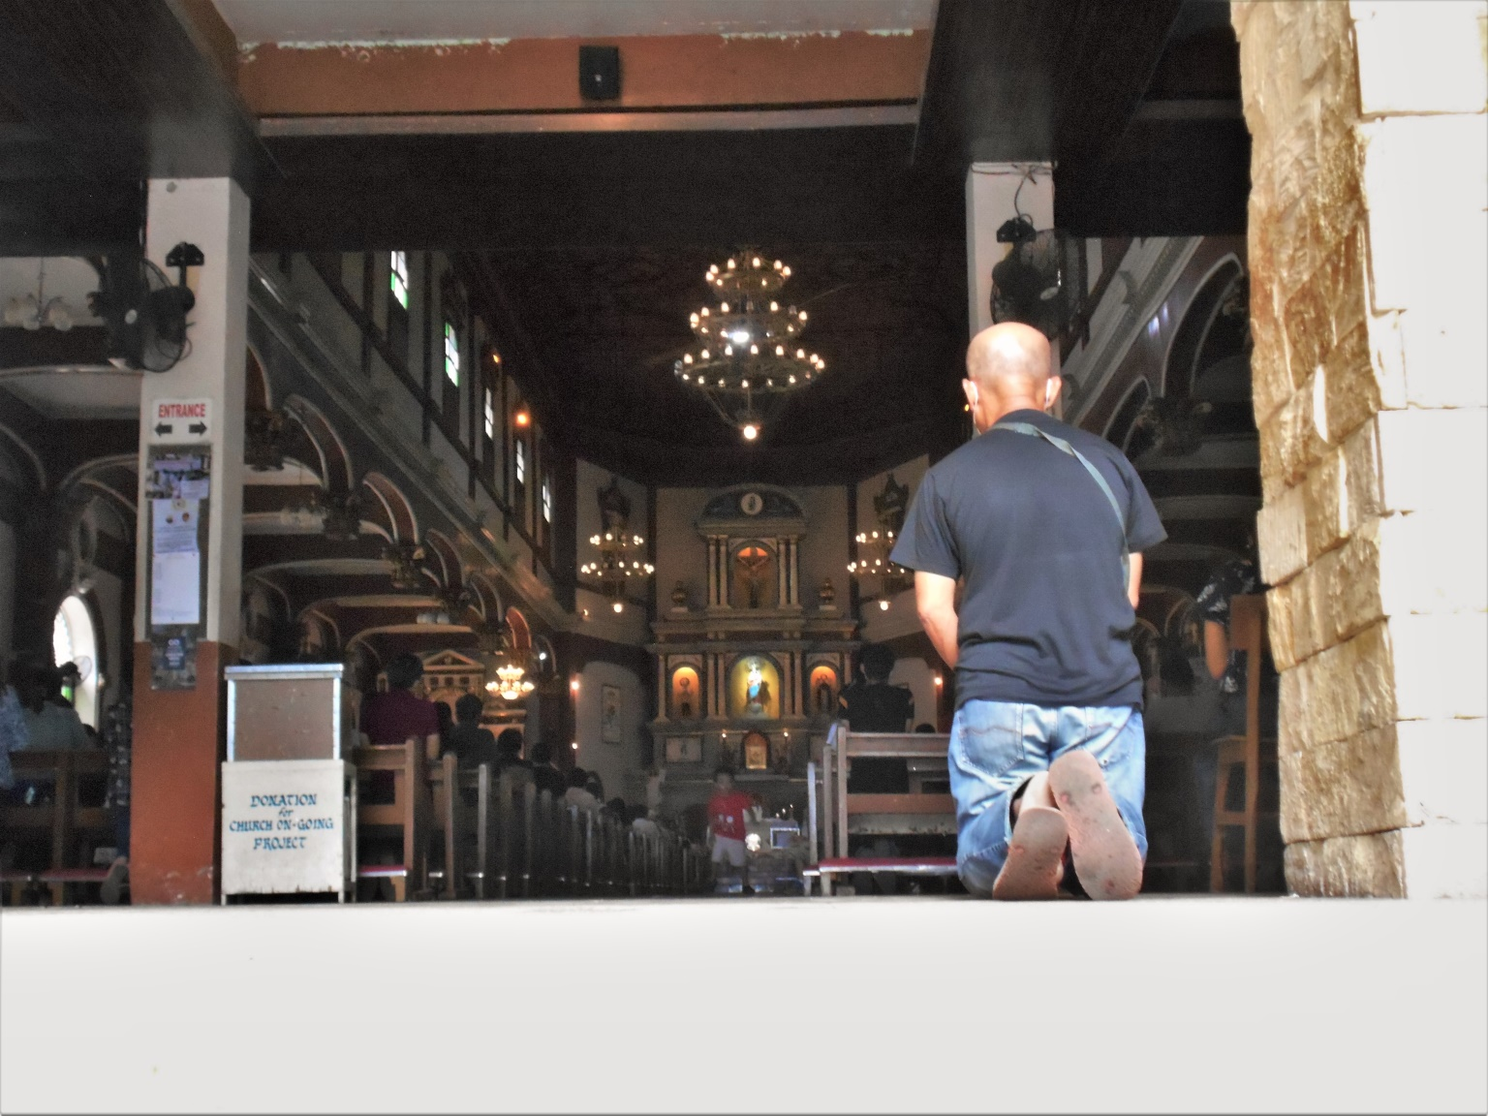.

*A Lifetime of Devotion: An old man’s quiet presence brings reverence to the church door.*

.

*Innocent Wonder: A child’s wide-eyed stare as he peeks through the car window.*

.

*Prayers in the Dark: A woman offering her prayers in front of the saints in the glow of unlighted candles.*